

**PERSONAL ASSISTANCE FOR SENIORS WHO ARE SELF-RELIANT**

**NALAIYA THIRAN PROJECT BASED LEARNING**

**On**

**PROFESSIONAL READINESS FOR INNOVATION, EMPLOYABILITY AND ENTREPRENEURSHIP**

**A PROJECT REPORT**

| KARTHICK BALA K | 19106053 |
| --- | --- |
| KARTHIKEYAN S | 19106055 |
| LINKESHVARAN R | 19106063 |
| MONISH K | 19106073 |

**BACHELOR OF ENGINEERING**

**IN**

**ELECTRONICS AND COMMUNICATION ENGINEERING**

**HINDUSTHAN COLLEGE OF ENGINEERING AND TECHNOLOGY**

Approved by AICTE, New Delhi, Accredited with ‘A’ Grade by NAAC

**(An Autonomous Institution, Affiliated to Anna University, Chennai)**

**COIMBATORE – 641 032**

November 2022

**CONTENTS**

| **TITLE** | **PAGE NO** |
| --- | --- |
| **1. INTRODUCTION** | **4** |
| a. Project Overview | 4 |
| b. Purpose | 4 |
| **2. LITERATURE SURVEY** | **4** |
| a. Existing problem | 4 |
| b. References | 4 |
| c. Problem Statement Deﬁnition | 4 |
| **3. IDEATION & PROPOSED SOLUTION** | **5** |
| a. Empathy Map Canvas | 5 |
| b. Ideation & Brainstorming | 6 |
| c. Proposed Solution | 7 |
| d. Problem Solution ﬁt | 8 |
| **4. REQUIREMENT ANALYSIS** | **9** |
| a. Functional requirement | 9 |
| b. Non-Functional requirements | 9 |
| **5. PROJECT DESIGN** | **10** |
| a. Data Flow Diagrams | 10 |
| b. Solution & Technical Architecture | 10 |
| **6. PROJECT PLANNING & SCHEDULING** | **11** |
| a. Sprint Planning & Estimation | 11 |
| b. Sprint Delivery Schedule | 12 |
| c. Reports from JIRA | 12 |
| **7. CODING & SOLUTIONING** | **13** |
| a. Feature 1 | 13 |
| b. Feature 2 | 14 |

| **8.TESTING** | **14** |
| --- | --- |
| i. Test Cases | 14 |
| i. User Acceptance Testing | 14 |
| **9.RESULTS** | **14** |
| a. Performance Metrics | 14 |
| **10.ADVANTAGES & DISADVANTAGES** | **15** |
| **11.CONCLUSION** | **15** |
| **12.FUTURE SCOPE** | **16** |
| **13.APPENDIX** | **16** |
| **Source Code** | **16** |
| **GitHub & Project Demo Link** | **16** |

# INTRODUCTION:

* 1. **PROJECT OVERVIEW:**

This project helps for the patient to take medicine at correct

time.sometimes elderly people forget to take their medicine at the correct time,they also forget which medicine he/she should take at the particular time and it is diﬃcult for doctors/caretakers to monitor the patients around the lock.to avoid these kind of

problems.medicine reminder system is developed.

# 1.2.PURPOSE:

The main purpose of this system is to remind the medicine name to the patient at the correct a time by sending voice command through iot device/mobile

phone.

# LITERATURE SURVEY:

* 1. **EXISTING PROBLEM:**

Patients who are suffering to identify their daily medicines due to their carelessness which causes health issues in their body and damage internal organs .by forgetting their medicines they risk their life in danger.

# 2.2.REFERENCES:

Slagle, J.M., Gordon, J.S., Harris, C.E., Davison, C.L., Culpepper, D.K.,Scott P. and Johnson, K.BZao, J.K., Wang, M.Y., Peihsuan, T. and Liu, J.W.S,Prasad, B.,S.T.-B. Hamida, E. Ben Hamida, B. Ahmed, and A. AbuDayya.

# 2.3.PROBLEM STATEMENT DEFINITION:

Senior citizens forget to take medication dues to their underlying medical condition called “Dementia”.

# IDEATION PROPOSED SOLUTION:

* 1. **EMPATHY MAP CANVAS:**

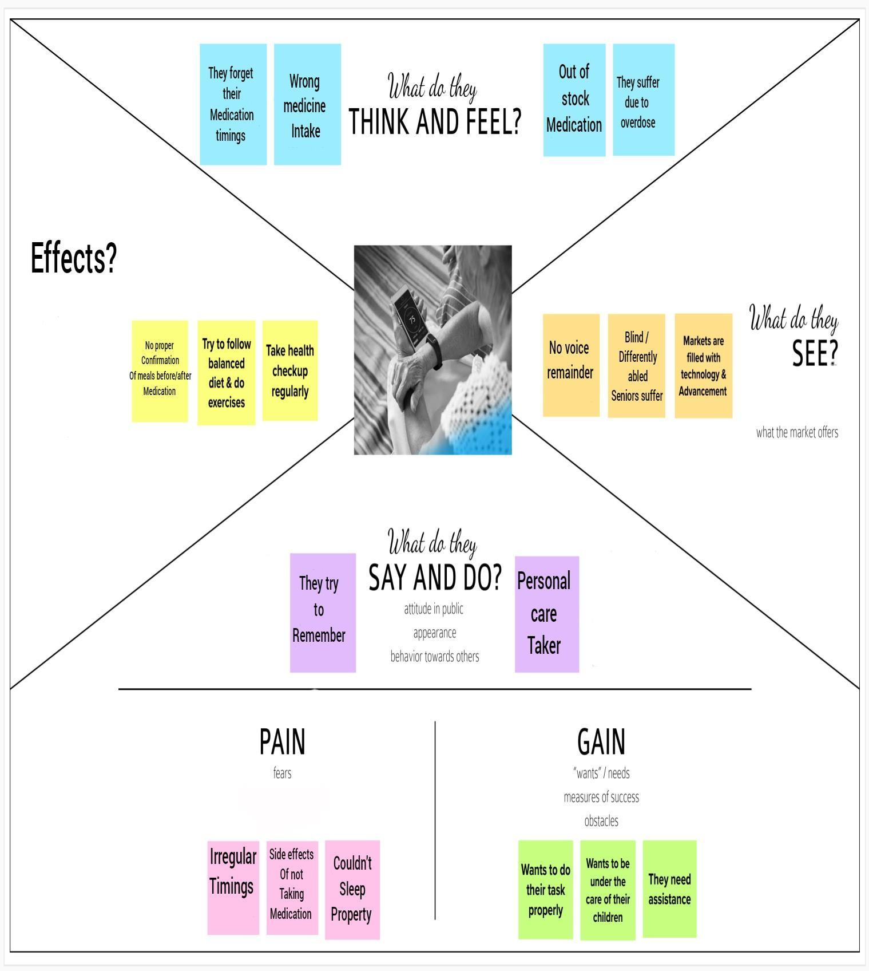

* 1. **IDEATION AND BRAINSTORMING**

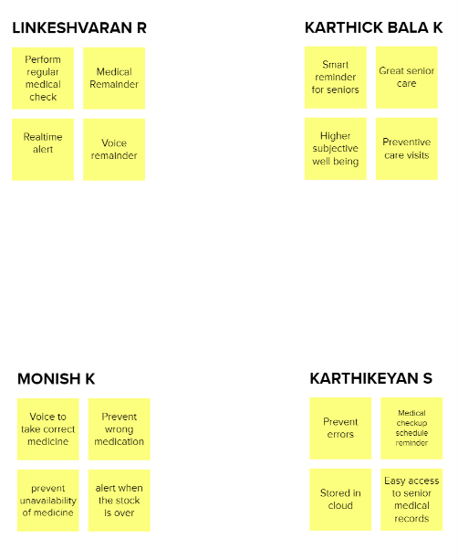

* 1. **PROPOSED SOLUTION:**

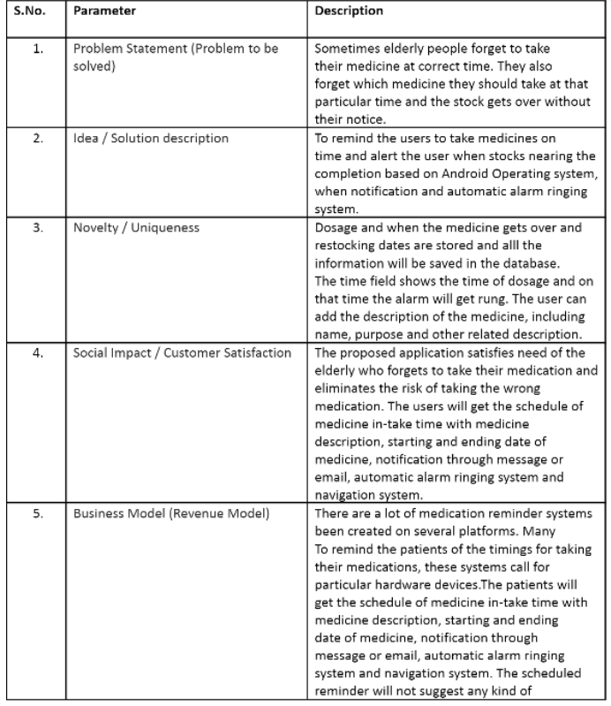

# PROBLEM SOLUTION FIT:

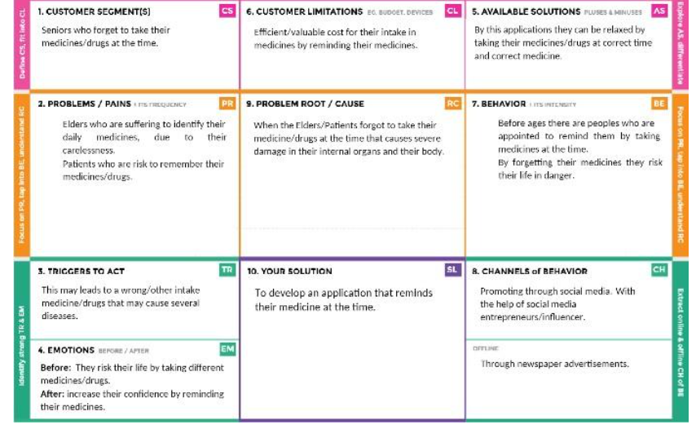

1. **REQUIREMENT ANALYSIS:**

# FUNCTIONAL REQUIREMENTS:

| **FR No.** | **Functional Requirement (Epic)** | **Sub Requirement (Story / Sub-Task)** |
| --- | --- | --- |
| FR-1 | Patient/User Registration | Registration through Form Registration through Gmail |
| FR-2 | User Conﬁrmation | **For Hospital Administration:**  Conﬁrm through the authorised card or identity of the hospital  **For Individual:**  Conﬁrmation via Email  Conﬁrmation via OTP |
| FR-3 | Patient/User Medical Detail  Submission | Enter the Prescription/Medicine details in the Cloud  Services (IBM Cloud, Drive) |
| FR-4 | Set Patient/User Desired Time | Enter the desired time in the application for which it  gives reminder through text/speech |

* 1. **NON-FUNCTIONAL REQUIREMENTS:**

| **FR No.** | **Non-Functional Requirement** | **Description** |
| --- | --- | --- |
| NFR-1 | **Usability** | This Application/Device will be useful for  literates/illiterates |
| NFR-2 | **Security** | Data entered will be secured through data synchronization and it is secured by giving  username and password |
| NFR-3 | **Reliability** | More reliable when compared with other  Apps/Devices |
| NFR-4 | **Performance** | Performance will be better and useful to the users  compared to other products |
| NFR-5 | **Availability** | Available on mobile app. Web version is getting  ready for next release. Prototype is on-progress |
| NFR-6 | **Scalability** | Once the data is uploaded, it won’t be erased until  the next data is uploaded |

# PROJECT DESIGN:

* 1. **DATA FLOW DIAGRAM:**

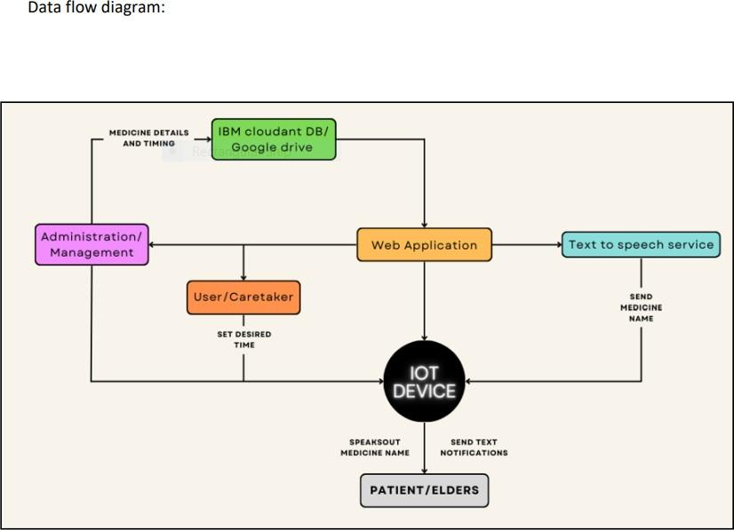

# SOLUTION AND TECHNICAL ARCHITECTURE:

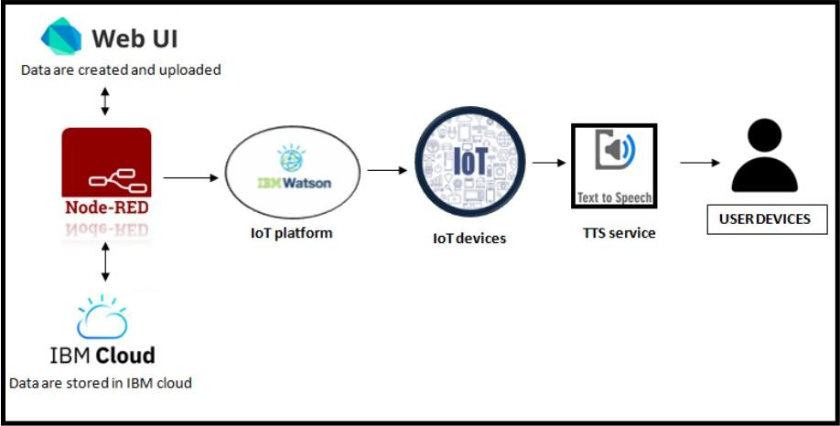

1. **PROJECT PLANNING AND SHEDULING:**

**6.1 SPRINT PLANNING AND ESTIMATION:**

| **Sprint** | **Functional Requirement (Epic)** | **User Story Number** | **User Story / Task** | **Story Points** | **Priority** | **Team Members** |
| --- | --- | --- | --- | --- | --- | --- |
| Sprint-1 |  | US-1 | Create the IBM Cloud services which are being used in this project. | 6 | High | Karthick Bala K  Karthikeyan S  Linkeshvaran R  Monish K |
| Sprint-1 |  | US-2 | Configure the IBM Cloud services which are being used in completing this project. | 4 | Medium | Karthick Bala K  Karthikeyan S  Linkeshvaran R  Monish K |
| Sprint-1 |  | US-3 | IBM Watson IoT platform acts as the mediator to connect the web application to IoT devices, so create the IBM Watson IoT platform. | 5 | Medium | Karthick Bala K  Karthikeyan S  Linkeshvaran R  Monish K |
| Sprint-1 |  | US-4 | In order to connect the IoT device to the IBM cloud, create a device in the IBM Watson IoT platform and get the device credentials. | 5 | High | Karthick Bala K  Karthikeyan S  Linkeshvaran R  Monish K |
| Sprint-2 |  | US-1 | Configure the connection security and create API keys that are used in the Node-RED service for accessing the IBM IoT Platform. | 10 | High | Karthick Bala K  Karthikeyan S  Linkeshvaran R  Monish K |
| Sprint-2 |  | US-2 | Create a Node-RED service. | 10 | High | Karthick Bala K  Karthikeyan S  Linkeshvaran R  Monish K |
| Sprint-3 |  | US-1 | Develop a APPLICATION that  reminds elders to take their medicines. | 7 | High | Karthick Bala K  Karthikeyan S  Linkeshvaran R  Monish K |
| Sprint-3 |  | US-2 | After that upload the information to the device that reminds them to take their medicine | 5 | Medium | Karthick Bala K  Karthikeyan S  Linkeshvaran R  Monish K |

| Sprint-3 |  | US-3 | Publish Data to The IBM Cloud | 8 | High | Karthick Bala K  Karthikeyan S  Linkeshvaran R  Monish K |
| --- | --- | --- | --- | --- | --- | --- |
| Sprint-4 |  | US-1 | Create Web UI in Node- Red | 10 | High | Karthick Bala K  Karthikeyan S  Linkeshvaran R  Monish K |
| Sprint-4 |  | US-2 | Configure the Node- RED flow to receive data from the IBM IoT platform and also use Cloudant DB nodes to store the received sensor data in the cloudant DB | 10 | High | Karthick Bala K  Karthikeyan S  Linkeshvaran R  Monish K |

* 1. **SPRINT DELIVERY SHCEDULE:**

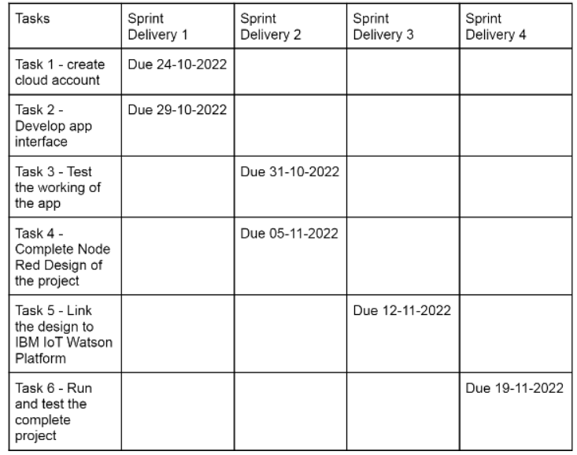

* 1. **REPORTS FROM JIRA:**

[**REPORT FROM JIRA REGARDING SPRINT DELIVERY**](https://drive.google.com/drive/folders/1lHfomz-J03bl_ww0pVtNnjrS6DJil4Ev?usp=share_link)

1. **CODING AND SOLUTIONING:**
   1. **FEATURE 1(NODE RED OUTPUT)**

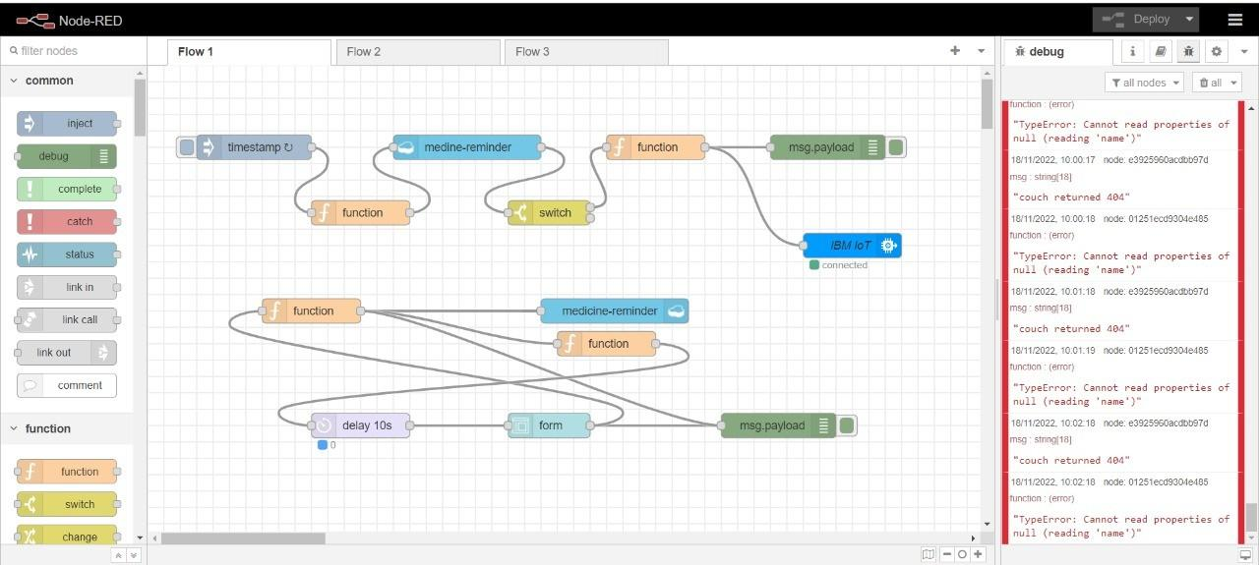

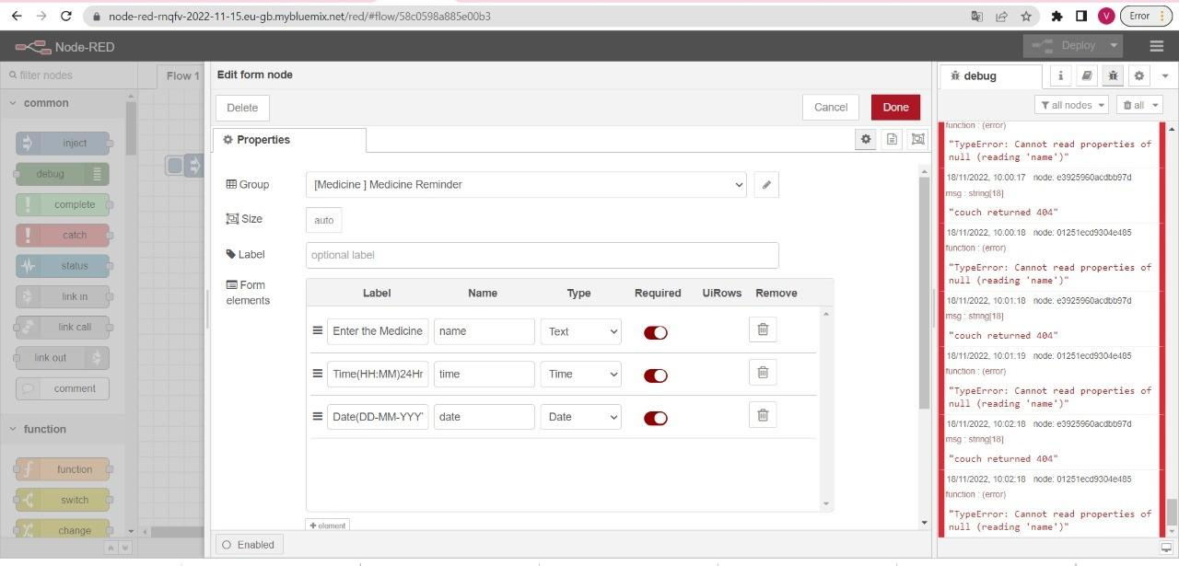

* 1. **FEATURE 2(PYTHON CODE OUTPUT):**

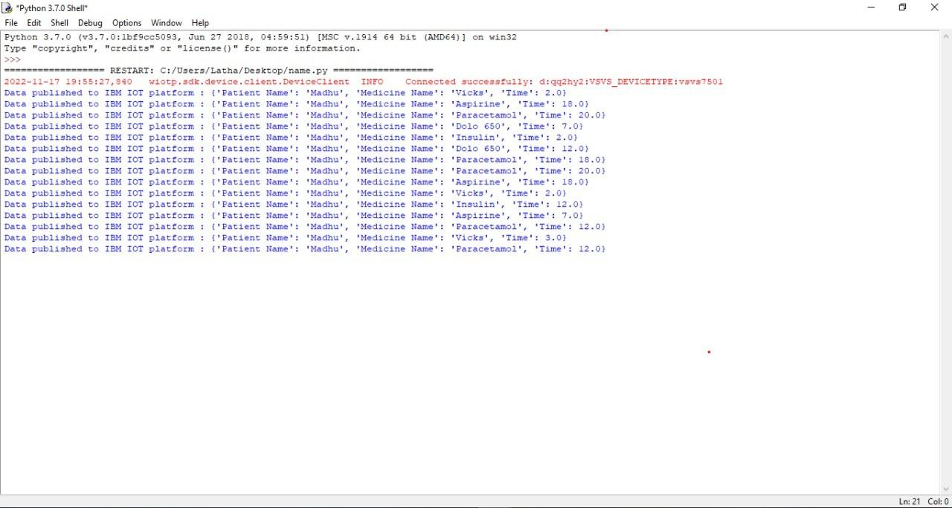

1. **TESTING:**
2. **Test Cases link:**

[**TEST CASE**](https://docs.google.com/spreadsheets/d/1aKnbzJYl0jdylGSFjMXEiGNGtknJfy_ldl6Gl1vZSJc/edit?usp=sharing)

1. **User Acceptance Testing link :**

[**USER ACCEPTANCE TESTING**](https://docs.google.com/document/d/16Tn2WAUlV13KLvvouK51ObchcNxeLS6n/edit?usp=sharing&ouid=100807295086684775026&rtpof=true&sd=true)

1. **RESULT:**

**i. Performance Metrics link :**

[**PERFORMANCE METRICS**](https://docs.google.com/spreadsheets/d/1MFSnNjRSh78F_y1onqE-jToBgQuAGAG0eLzOzdXwbG0/edit?usp=sharing)

1. **ADVANTAGES AND DISADVANTAGES:**

ADVANTAGES:

* Patient can easily take medicine at correct time
* It increase patient satisfaction
* avoid the diﬃculties for doctors/caretaker
* Help in decreasing medication dispensing errors
* Easy to use
* Time saving for users

DISADVANTAGES:

* If seniors/patients who are physically disabled (like deaf) ,they can’t hear the voice command
* If seniors/patients who are visually challenged (like cataracts)and illiterate, they can’t read the medicine/drugs name properly

1. **CONCLUSION:**

Reminder systems are a complex intervention, because of the potential number of interacting components within the interventions, the requirement for tailoring of the intervention to the health service and the number of difficulties and behavioural changes from those receiving and delivering the reminder.

Therefore, in addition to following the general recommendations provided above, health service managers will need to tailor their reminder systems to meet the needs of the service and the patient population that it serves. This review provides a range of findings that will inform health service managers’ decision- making processes. To this end, we are producing a practice guide to help health service managers consider specific issues that may be relevant to the design of reminder systems for their health service.

# FUTURE SCOPE:

Patients/elders can individually take their medicine without the help of others.it is very useful for patients whose age in between 50-80.there is no need to depend others for taking medicine.main acception of this medicine reminder system is,notiﬁcation will be sent through the voice command not by alarm.so patient can easy identify their medicine name.It is very helpful for the patients who are suffered from metabolic disorder,cardigenic shock,heart attack,pneumonia,diabetics,cancer etc..

# APPENDIX:

**SOURCE CODE:**

[**SOURCE CODE LINK**](https://github.com/IBM-EPBL/IBM-Project-38768-1660385236/blob/main/Final%20Deliverables/source%20code.py)

**GITHUB AND PROJECT DEMO LINK:**

[**GITHUB LINK**](https://github.com/IBM-EPBL/IBM-Project-38768-1660385236)

**PROJECT DEMO LINK:**

[**PROJECT DEMO LINK**](https://github.com/IBM-EPBL/IBM-Project-38768-1660385236)